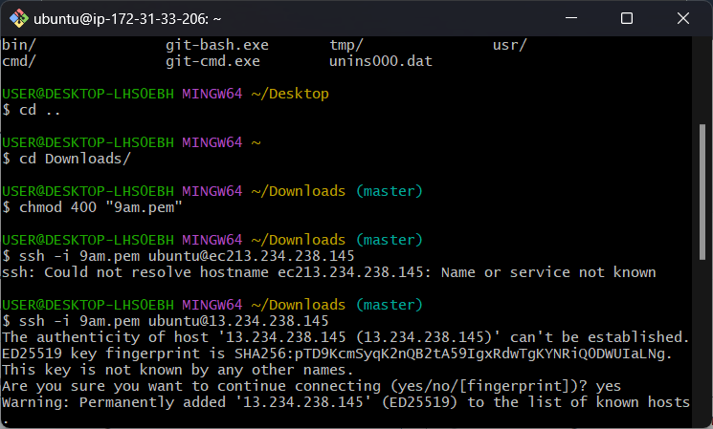

1.taking ssh remote connection from git bash

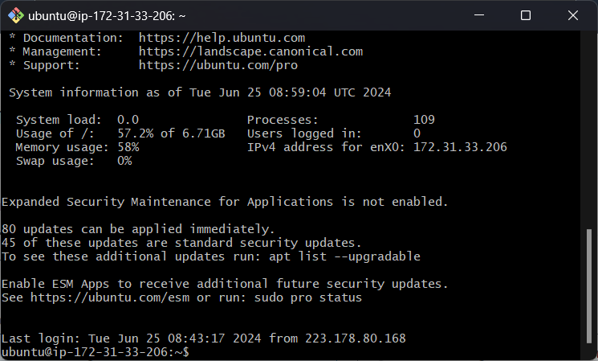

2.loged in to the machine from git bash